Hitansh Gopani
Roll no:15

#include <stdio.h>
#include<malloc.h>
typedef struct node
{
int data;
struct node *next;
} node;
node *createList();
node *Insert_beg(node *head, int x);
node *Insert_end(node *head, int x);
node *Insert_mid(node *head, int x);
node *Delete_beg(node *head);
node *Delete_end(node *head);
node *Delete_mid(node *head);
void PrintList(node *head);
void main()
{
int choice, insert_option, delete_option, x;
node *head = NULL;
printf("Welcome to the implementation of the singly linked list ! \n");
do
{
printf("Please select an operation to perform from the below list \n");
printf(" 1. Create a List \n 2. Insert a node \n 3. Delete a node \n 4. Print the existing list \n 5. Exit \n");
printf("Enter your choice: ");
scanf("%d", &choice);
printf("\n \n");
switch (choice)
{
case 1:
head = createList();
break;
case 2:
do
{
printf("Select a position where you to want to insert new node \n");
printf(" 1. Beginning of the List \n 2. At the end of the list \n 3. Insert in between \n 4. Exit the insert operation \n");
printf("Enter your choice: ");
scanf("%d", &insert_option);
switch (insert_option)
{
case 1:
printf("Enter the data to be inserted: ");
scanf("%d", &x);
head = Insert_beg(head, x);
break;
case 2:
printf("Enter the data to be inserted: ");
scanf("%d", &x);
head = Insert_end(head, x);
break;
case 3:
printf("Enter the data to be inserted: ");
scanf("%d", &x);
head = Insert_mid(head, x);
break;
case 4:
printf("Insert operation Exit");
break;
default:
printf("Please enter a valid choide: 1, 2, 3, 4");
}
} while (insert_option != 4);
printf("\n \n");
break;
case 3:
do
{
printf("Select a position from where you to want to delete the element \n");
printf(" 1. Beginning of the List \n 2. At the end of the list \n 3. Somewhere in between \n 4. Exit the delete operation \n");
printf("Enter your choice: ");
scanf("%d", &delete_option);
switch (delete_option)
{
case 1:
head = Delete_beg(head);
break;
case 2:
head = Delete_end(head);
break;
case 3:
head = Delete_mid(head);
break;
case 4:
printf("Delete Operation Exit");
break;
default:
printf("Please enter a valid choide: 1, 2, 3, 4");
}
} while (delete_option != 4);
printf("\n \n");
break;
case 4:
PrintList(head);
break;
case 5:
printf("Exit: Program Finished !!");
break;
default:
printf("Please enter a valid choide: 1, 2, 3, 4, 5");
}
} while (choice != 5);
}
node *createList()
{
node *head, *p;
int i, n;
head = NULL;
printf("Enter the number of nodes: ");
scanf("%d", &n);
printf("Enter the data: ");
for (i = 0; i <= n - 1; i++)
{
if (head == NULL)
{
p = head = (node *)malloc(sizeof(node));
}
else
{
p->next = (node *)malloc(sizeof(node));
p = p->next;
}
p->next = NULL;
scanf("%d", &(p->data));
}
printf("\n \n");
return (head);
}
node *Insert_beg(node *head, int x)
{
node *p;
p = (node *)malloc(sizeof(node));
p->data = x;
p->next = head;
head = p;
return (head);
}
node *Insert_end(node *head, int x)
{
node *p, *q;
p = (node *)malloc(sizeof(node));
p->data = x;
p->next = NULL;
if (head == NULL)
return (p);
for (q = head; q->next != NULL; q = q->next)
;
q->next = p;
return (head);
}
node *Insert_mid(node *head, int x)
{
node *p, *q;
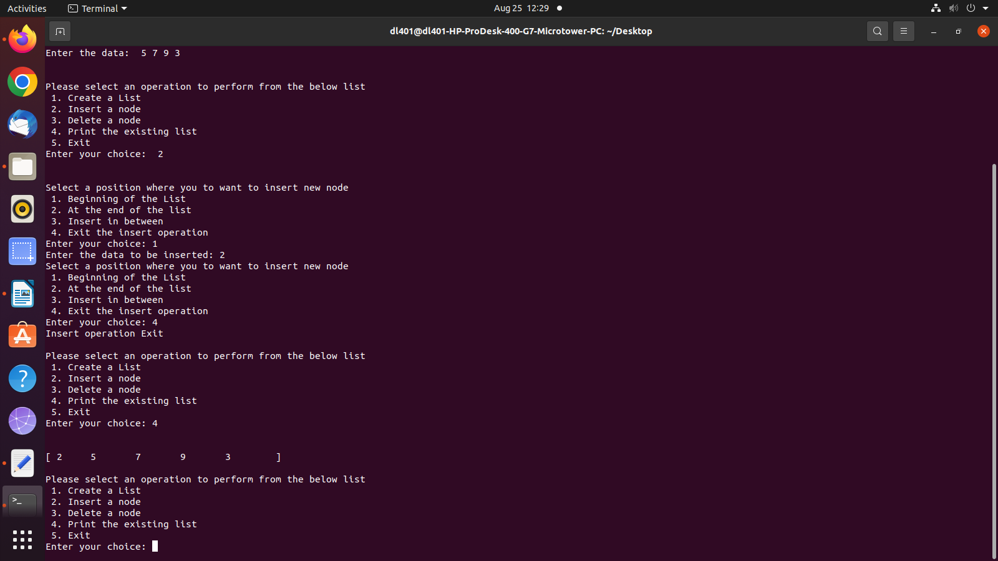
int y;
p = (node *)malloc(sizeof(node));
p->data = x;
p->next = NULL;
printf("After which element you want to insert the new element ?");
scanf("%d", &y);
for (q = head; q != NULL && q->data != y; q = q->next)
;
if (q != NULL)
{
p->next = q->next;
q->next = p;
}
else
printf("ERROR !! Data Not Found");
return (head);
}node *Delete_beg(node *head)
{
node *p, *q;
if (head == NULL)
{
printf("Empty Linked List");
return (head);
}
p = head;
head = head->next;
free(p);
return (head);
}
node *Delete_end(node *head)
{
node *p, *q;
if (head == NULL)
{
printf("Empty Linked List");
return (head);
}
p = head;
if (head->next == NULL)
{
head = NULL;
free(p);
return (head);
}
for (q = head; q->next->next != NULL; q = q->next)
p = q->next;
q->next = NULL;
free(p);
return (head);
}
node *Delete_mid(node *head)
{
node *p, *q;
int x, i;
if (head == NULL)
{
printf("Empty Linked List");
return (head);
}
printf("Enter the data to be deleted: ");
scanf("%d", &x);
if (head->data == x)
{
p = head;
head = head->next;
free(p);
return (head);
}
for (q = head; q->next->data != x && q->next != NULL; q = q->next)
if (q->next == NULL)
{
printf("ERROR !! Data Not Found");
return (head);
}
p = q->next;
q->next = q->next->next;
free(p);
return (head);
}

void PrintList(node *head)
{
node *p;
printf("[ ");
for (p = head; p != NULL; p = p->next)
{
printf("%d \t", p->data);
}
printf(" ]");
printf("\n \n");
}

